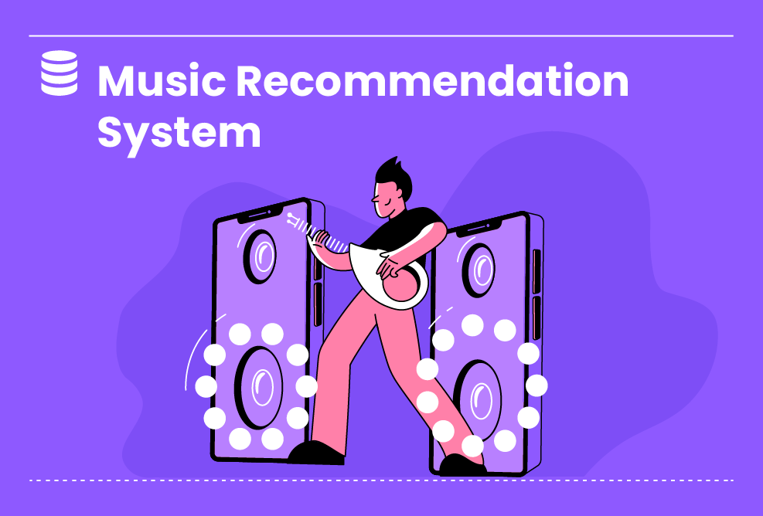

Not So Easy

**Music Recommendation System🎶**

In this project, you will build a music recommendation system using the Spotify dataset. The system will analyze user listening habits and music features to provide personalized music recommendations.

Worked on this project

Duration : 52 Hours

Not So Easy

4 Steps

**Project Objective**

The objective of this project is to develop a recommendation algorithm that leverages the Spotify dataset to suggest music based on user preferences and music attributes.

**Inspiring Project Examples**

https://www.youtube.com/watch?v=n3RKsY2H-NE

https://www.youtube.com/watch?v=Q8W2IGiSdhc

https://www.youtube.com/watch?v=f2UvkinbLaw

**Step By Step**

On this project, you will pass by these steps. All steps must be done to successfully complete this project.

**Reading Data**

In This Phase, The Objective Is To Read The Spotify Dataset And Explore Its Contents. This Step Is Crucial For Understanding The Data Structure And Preparing It For Subsequent Phases Of The Project.

**Exploratory Data Analysis**

In This Phase, You Will Conduct Exploratory Data Analysis On The Spotify Dataset. This Analysis Will Help You Understand Trends In Sound Features Over Decades, Examine The Popularity And Characteristics Of Top Genres And Artists, And Generate Word Clouds To Visualize The Genres And Artists Present In The Dataset.

**Clustering Phase**

In This Phase, We Will Use Clustering Techniques To Group Genres And Songs Based On Their Characteristics. Clustering Helps In Discovering Patterns And Similarities Within The Dataset, Enabling Us To Gain Insights Into The Structure Of The Music Data.

**Modeling (Recommendation System)**

In This Phase, We Will Use The Spotify Dataset And Implement A Recommendation System Using Song Features. We Will Utilize The Spotipy Library To Access The Spotify API And Fetch Additional Song Details. The Recommendation System Will Calculate The Similarity Between Songs Based On Their Numerical Features And Recommend The Top 10 Similar Songs To The User.

**Instructor Guideline**

1. Familiarize yourself with the Spotify dataset and understand the available features and attributes. 2. Discuss different recommendation techniques, such as collaborative filtering, content-based filtering, and hybrid approaches, that can be applied to the Spotify dataset. 3. Help students understand the data preprocessing steps required, including handling missing values, normalization, and feature engineering. 4. Guide students in implementing and evaluating different recommendation algorithms using the Spotify dataset. 5. Provide resources and support for students to learn how to use the Spotify API, if applicable.

**Guidelines Ressources**

https://www.kaggle.com/code/vatsalmavani/music-recommendation-system-using-spotify-dataset